Statistics on Child Soldiers

1. Total numbers
The numbers of child soldiers are constantly fluctuating in accordance with the evolution of different armed conflicts. So it’s difficult to estimate how many child soldiers there are at any time, a difficulty compounded by the inherent secrecy of it all. Shady recruiters aren’t likely to divulge statistics, and wartime conditions make everything difficult, including measurement. Human Rights Watch estimates that 200,000 to 300,000 children are currently serving as soldiers for both rebel groups and government forces in armed conflicts. The best guess is that 100.000 of those fight in Africa. Myanmar also has a large number of child soldiers, although not in rebel groups but in the government armed forces. Soldiers under age 18 were reported in 21 armed conflicts in 2002-2007. The proportion of child soldiers in some armed groups was up to 70%
Most child soldiers are boys, but girls are a substantial minority. Many children in fact volunteer, because life as a soldier often looks better than the misery and poverty they try to leave behind. About 2/3 volunteer. “Volunteer” is of course a stretch sometimes: maybe they are forced by poverty or maybe they want to revenge their community. Abduction is the exception. A majority of child soldiers are adolescents, between the ages of 15 and 18.

2. Geographical breakdown
At present, armed groups operating in 21 countries use children as soldiers. There are 8 government armies listed for the recruitment and use of children, although 6 of them have already committed to making their armies child-free. In 2012, South Sudan, Myanmar, Somalia and the Democratic Republic of Congo signed action plans with the United Nations. The previous year, Afghanistan and Chad made similar commitments. Discussions initiated with the Governments of Yemen and Sudan are expected to lead to action plans in the near future (source).
This map shows the countries where there were child soldiers active in armed conflict in 1998:
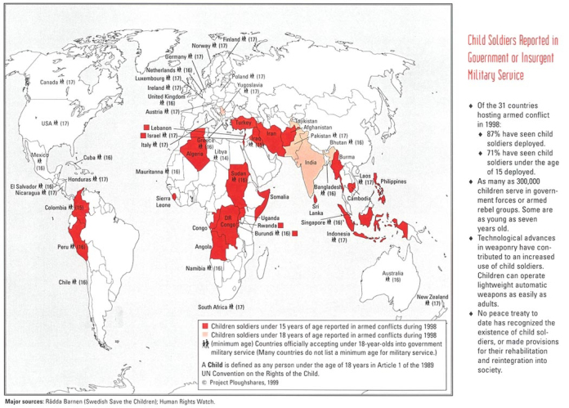
And this map is a bit more specific on the African situation since Africa has without any doubt the largest number of child soldiers (although the problem exists also in South Asia, most notably in Myanmar):
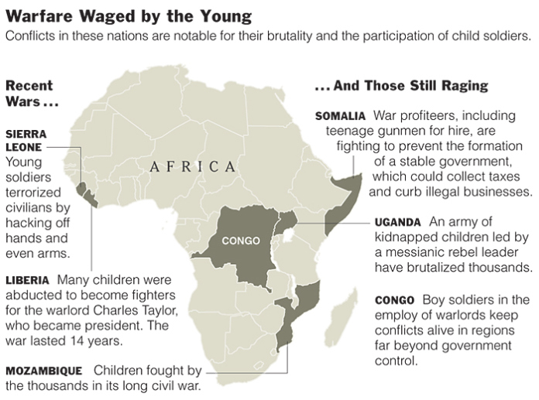

3. Case study: The Lord’s Resistance Army (LRA)
The Lord’s Resistance Army is a religious and military group formed in 1987 and headed by Joseph Kony, who claims to be the “spokesperson” of God and a spirit medium, primarily of the Holy Spirit. The inspiration is mainly Christian. The LRA first engaged in an armed rebellion against the Ugandan government, but later moved its activities to parts of Sudan, Central African Republic and DR Congo. It’s infamous for widespread human rights violations, including murder, abduction, mutilation, sexual enslavement of women and children, and forcing children to participate in hostilities.
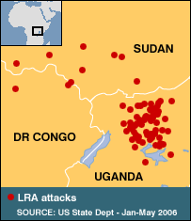
Currently, the LRA seems to have moved its operations away from Uganda:
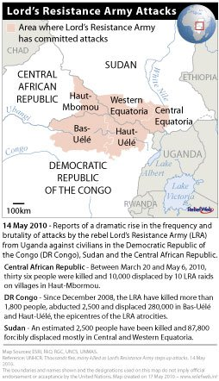

4. Why child soldiers?
Why are children recruited for warfare? Why not just use adults who are likely to be more capable and reliable soldiers?
- Children are relatively easy to abduct, subjugate, and manipulate. They are more impressionable and vulnerable to indoctrination, and their moral development is incomplete and malleable.
- They are also seen as more loyal and less threatening to adult leadership.
- Children, despite their a priori disadvantages in terms of fighting skills, may have a particular functional value. They may be suitable for menial logistical support of the armed group, or they may even have certain tactical advantages: they can slip through enemy lines unnoticed, making them effective spies and bomb carriers. Also, the proliferation of inexpensive, lightweight weapons has made it easier to use children as soldiers. These small arms are easy to transport and use with little training.
- Rebel groups also make simple cost-benefit analysis: children require less food and no payment. Punishment of children is also less costly. Child soldiers are financially attractive. Rebel groups may be extremely resource-constrained and forced to recruit children.
- The use of child soldiers can present a moral dilemma to enemies: should they kill children?
- Rebel groups may recruit children in order to signal seriousness, commitment and ruthlessness, and thereby instill fear in the enemy.

5. How are child soldiers recruited?
Patterns of recruitment of children vary according to the context. It’s usually a mix of punishment, promises of rewards and indoctrination.
- The recruitment of children is facilitated when they are forced to participate in an assassination (perhaps of one of their relatives, parents or friends). The objective is to break their will. The forced killing of relatives also destroys a child’s outside options: if the child were to flee, it has no place to go to, or the community may reject the child because of what it did.
- Armed forces will also destroy other outside options for children: schools, villages, farms etc.
- Armed forces abuse children’s feelings of desperation and traumas resulting from previous situations of extreme violence.
- Armed forces also abuse certain motivations of children: children may join armed forces because of the desire to take control of events, or because of the protection offered by being at the shooting end of a gun.

6. What can we do about it?
There’s an interesting paper by Blattman and Beber that looks at some of the things governments can do about child soldiering. Child soldiers are often recruited by insurgent groups. Governments can decide to increase counter-insurgency efforts in order to stop the insurgents from recruiting children. But this counter-insurgency increases the minimum force size requirement for the rebel group, hence also the rebel leaders’ incentives to abduct children.
Now suppose the government reaction is not to step up hostilities but to develop educational and economic opportunities for children so that children have larger outside choices which make it more likely that they escape from and less likely that they are lured by the rebels. However, according to Blattman and Beber, intermediate levels of development of such choices could push the optimal age of recruitment of child soldiers downwards. And if outside choices increase, the incentives for the rebel group to take over the country also increase. If rebel group incentives increase, the incentives to recruit children also increase.
Source: http://filipspagnoli.wordpress.com/stats-on-human-rights/statistics-on-war-conflict/statistics-on-child-soldiers/

