Unit 2 Public Practice World Geography 3202

- What concept is best illustrated below?

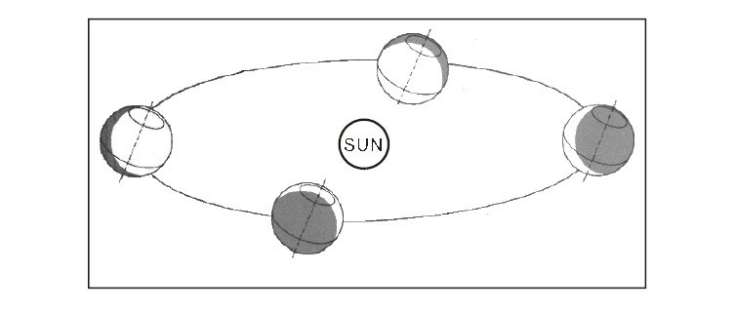
  - coriolis effect
  - global warming
  - revolution
  - rotation

- What is the effect of a clear, cloudless sky on Earth?

  - day and night temperatures are cooler
  - day and night temperatures are warmer
  - nights are cooler and days are warmer
  - nights are warmer and days are cooler
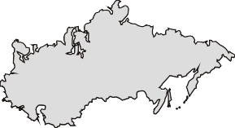
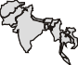
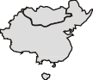
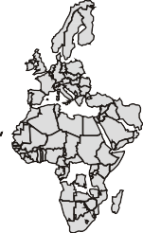
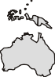
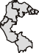
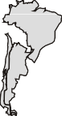
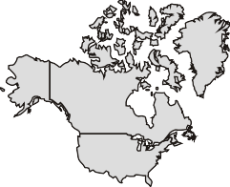
- Which factor is most responsible for differences in temperature at X and Y below?

  - altitude
  - latitude
  - ocean currents
  - prevailing winds

- Which refers to the most common wind direction at a given location?

  - monsoon winds
  - prevailing winds
  - trade winds
  - westerly winds

- Which statement is true regarding the development of sea breezes?

  - high pressure developing over land
  - land heating up much faster than ocean
  - low pressure developing over ocean
  - ocean heating up much faster than land

- What describes how the rotation of Earth causes freely moving water and air masses to be deflected from their original courses?

  - coriolis effect
  - high pressure
  - pressure zones
  - trade winds

- What is the horizontal movement of unusually warm or cold surface water?

  - convection cell
  - cyclone
  - ocean current
  - typhoon

- What is the difference between the highest and lowest temperature of a region?

  - average temperature
  - greenhouse effect
  - pressure belts
  - temperature range

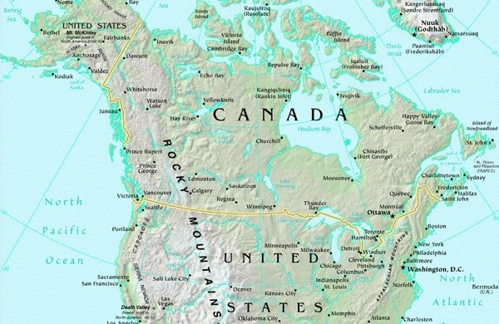
- What is the most common type of precipitation experienced at location X in the diagram below?

  - convectional
  - cyclonic
  - frontal
  - orographic

- Which is responsible for the four seasons on Earth?

  - elevation
  - prevailing winds
  - revolution
  - rotation

- Which is true regarding cloud cover and temperature range?

  - Cloud cover does not impact temperature range.
  - Cloud cover only impacts temperature range in the daytime.
  - Many clouds increase temperature range.
  - No cloud cover creates the greatest temperature range.

- Which describes the winter solstice in the Southern Hemisphere?

  - equal length of day and night
  - mid-day sun is directly overhead at its farthest point north
  - mid-day sun is directly overhead at its farthest point south
  - occurs twice per year

- Which best represents the impact of global warming on the Greenhouse Effect?

  - decreases precipitation
  - increases temperature
  - stabilizes precipitation
  - stabilizes temperature

- Which is true regarding the development of a land breeze?

  - high pressure develops over the sea
  - land cools faster than the sea
  - low pressure develops over the land
  - ocean cools faster than the land

- Which describes the impact of the Coriolis effect in the Southern Hemisphere?

  - Winds are deflected to the left of their paths.
  - Winds are deflected to the right of their paths.
  - Winds move from high to low pressure with no deflection.
  - Winds move from low to high pressure with no deflection.

- Which type of climate is represented below?

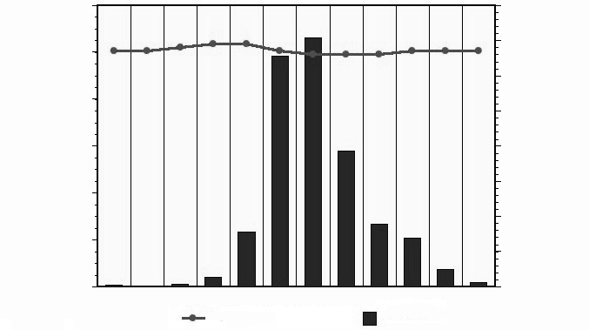
  - temperate cold
  - temperate mild
  - tropical wet
  - tropical wet and dry

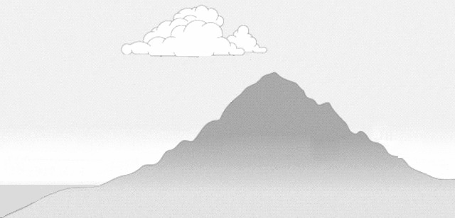
- At which location would the greatest amount of orographic rainfall occur?

Prevailing Wind

  - A
  - B
  - C
  - D

- Which creates the greatest temperature range from day to night?

- cloud cover for 24 hours
- cloudy in daytime only
- cloudy in night-time only
- no cloud cover

- Which is true regarding the equinoxes?

- direct rays of sun over Tropic of Cancer
- results in longest and shortest days
- same length of day and night
- takes place in June and December

- Which refers to the most common and dominant wind at a given location?

  - Hurricane
  - Monsoon
  - Prevailing
  - tornado

- How do night-time and temperature conditions at 40oN compare to 40oS?
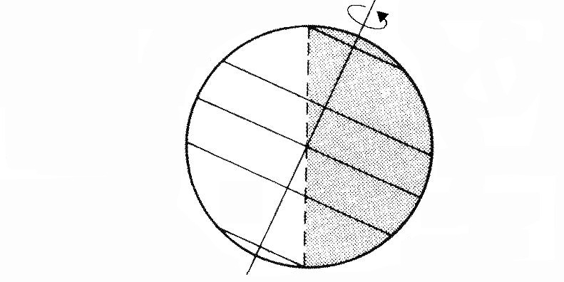
- fewer hours of night and cooler temperatures
- fewer hours of night and warmer temperatures
- more hours of night and cooler temperatures
- more hours of night and warmer temperatures

- Which is true regarding the development of a sea breeze?

- air is heavier over the land than the sea
- breeze moves from land to the sea
- sea cools down faster than land at night
- temperature of land is greater than the sea

- Which refers to distinct wet and dry seasons in the tropics?

- convection
- Coriolis effect
- prevailing wind
- monsoon

- Why are the North Polar Easterlies moving in the direction indicated in the diagram?
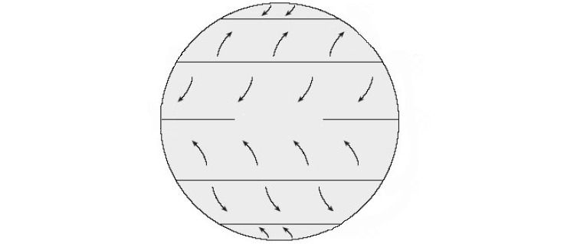

- high pressure at 60o north
- low pressure at the north pole
- winds move from high to low pressure
- winds move from low to high pressure

- Which climate region is described below?
•
•
•
temperature above 18EC everyday
rainfall year-round impacted by trade winds

- marine west coast
- mediterranean
- temperate mild winter
- tropical

- Which has the greatest impact on seasonal changes between the Northern and Southern hemisphere?

  - Earth’s revolution around the sun
  - Distance of the earth to the moon
  - Earth’s rotation on its axis
  - gravitational impact of the Moon on Earth

- What causes the deflection of the wind from the North Pole to Dallas, Texas?

  - Coriolis effect
  - Earth’s revolution
  - ocean currents
  - prevailing winds

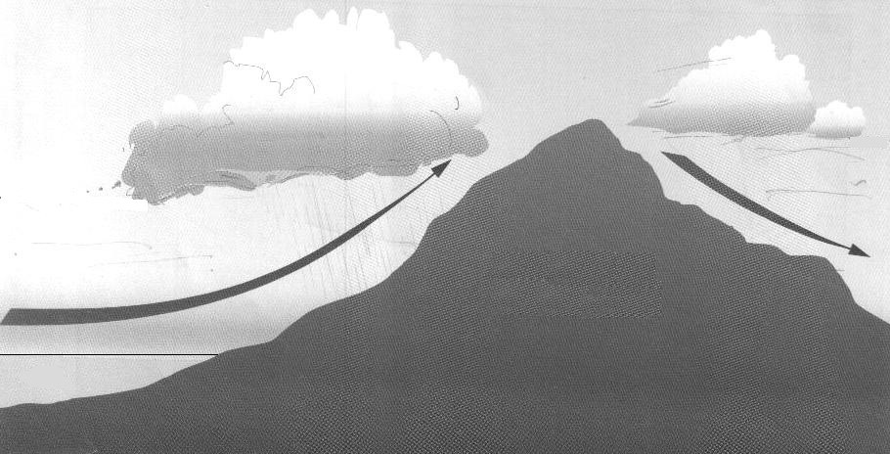
- Which is the driest location in the diagram below?
  - A
  - B
  - C
  - D

- What accounts for the fact that location X has cooler summer temperatures than location Y?
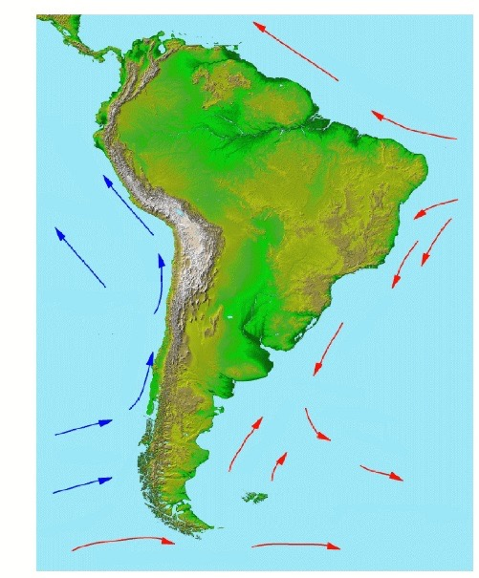

  - continentality
  - latitude
  - monsoons
  - ocean currents

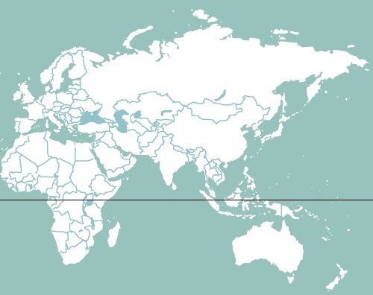
- Which location would have the greatest annual temperature range using the map below?

  - A
  - B
  - C
  - D

- What is the primary cause of monsoons?

  - altitude
  - longitude
  - ocean currents
  - pressure systems

- Which describes Earth’s rotation?

  - annual movement of Earth around the sun
  - changing distance of Earth from the sun
  - daily movement of Earth on its axis
  - tilt of Earth on its axis

- Which describes the equinoxes?

  - direct rays of the sun over the Tropic of Cancer
  - indirect rays of the sun over the poles
  - occur in June and December
  - same length of day and nigh

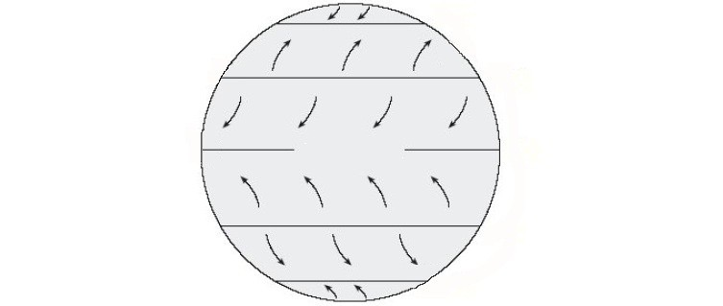
- Why are the prevailing winds, in the pressure belt identified X, moving in the direction indicated?

  - high pressure system at the equator
  - low pressure system at °
30
  - winds always move from high to low
  - winds always move from low to high

- What refers to the seasonal reversal of winds experienced in Southeast Asia?

  - easterlies
  - hurricanes
  - monsoons
  - westerlies

- Which statement is true regarding the development of land breezes?

  - high pressure developing over ocean
  - land cooling down much faster than the ocean
  - low pressure developing over land
  - ocean heating up much faster than the land

- In the graphic below, what is the most common type of rainfall experienced at location X?

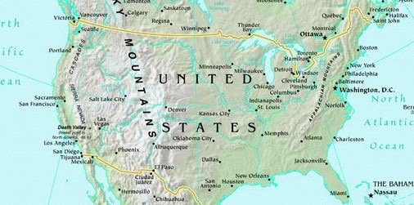

  - convectional
  - cyclonic
  - frontal
  - orographic

- Which refers to the distance of a location above sea level?

  - elevation
  - gradient
  - latitude
  - longitude

- Which location would experience the greatest temperature range in the graphic below?
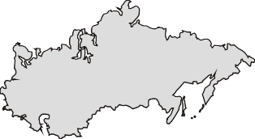
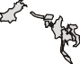
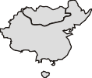
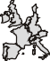
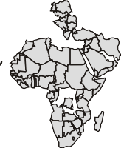
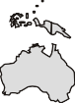
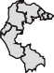
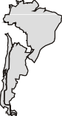
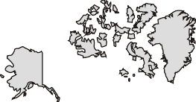
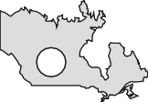

  - A
  - B
  - C
  - D

- How does cloud cover influence the range of temperatures from day to night?

  - temperature is unaffected by clouds
  - temperature range decreases
  - temperature range increases
  - temperatures remain constant

- What is identified by X in the Northern Hemisphere?
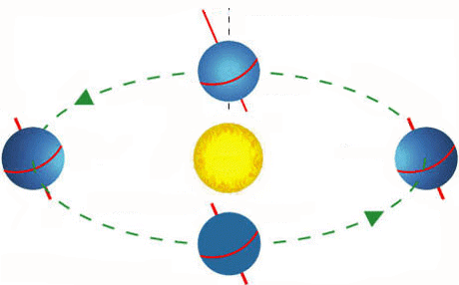
  - fall equinox
  - spring equinox
  - summer solstice
  - winter solstice

- What factors account for variations in sunlight hours as the seasons change?

  - coriolis effect and air pressure
  - prevailing winds and ocean currents
  - rotation and curvature of Earth
  - tilt and revolution

- Which explains why temperatures decrease as we move from the equator to the poles?

  - curvature of Earth
  - movement of air from high to low pressure belts
  - revolution of Earth around the sun
  - rotation of Earth on its axis

- What type of precipitation results when warm, moist air collides with cool, dry air?

  - convectional
  - frontal
  - orographic
  - relief

- What is the relationship between climate and elevation?

  - elevation has no influence on temperature and precipitation
  - the higher the elevation, the higher the temperature
  - the higher the elevation, the higher the precipitation
  - the higher the elevation, the lower the temperature

- What prevailing wind system is indicated by X in the graphic below?

  - Northeast Trade Winds
  - Polar Easterlies
  - Southeast Trade Winds
  - Prevailing Westerlies

- Which point will receive the highest amount of precipitation in the diagram below?
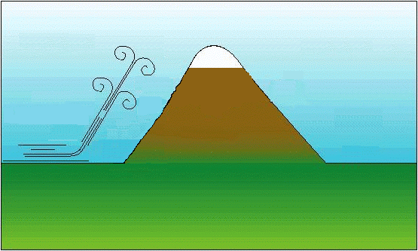
  - A
  - B
  - C
  - D

- Which climatic zone is illustrated in the climograph below?
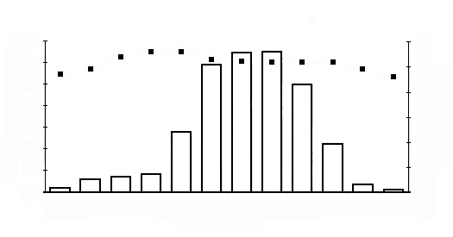
  - boreal forest
  - temperate
  - tropical wet
  - tropical wet and dry

CASE STUDY 1
Units 1-5 Tsunami
A tsunami is a wave train, or series of waves, generated in a body of water by a disturbance that vertically displaces the water column. Earthquakes, landslides, volcanic eruptions, explosions, and even the impact of cosmic bodies, such as meteorites, can generate tsunamis. Tsunamis can savagely attack coastlines, causing devastating property damage, loss of life, and environmental destruction.

Figure 1
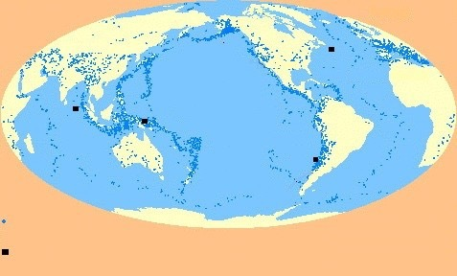
Tsunamis do not have a season and do not occur regularly or frequently. Yet they pose a major threat to the coastal populations of the Pacific. Nothing can be done to prevent them, but the adverse impact on the loss of life and property can be reduced with proper planning.

The undersea Indian Ocean earthquake that occurred on December 26, 2004, produced tsunamis that were among the deadliest natural disasters in modern history. The tsunamis devastated the shores of Indonesia, Sri Lanka, India, Thailand, and other countries with waves of up to 15 m high, even reaching Somalia on the east coast of Africa, 4 500 km west of the epicenter (point of origin). Over 225 000 people are known to have died as a result of the tsunami.

In the United States, the National Oceanic and Atmospheric Administration (NOAA) oversees the Tsunami Program, with its mission to provide a 24-hour detection and warning system and increase public awareness about the threat of tsunami. It provides warning bulletins to government authorities and the public. The Tsunami Ready Community program was created by the NOAA Weather Service to help communities become prepared for tsunamis through better
planning, education and

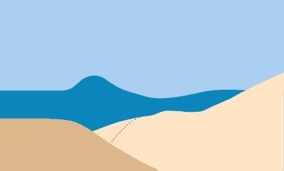
Figure 2

awareness. The program is voluntary and communities must meet certain criteria to receive the designation. The countries impacted by the 2004 Tsunami did not have access to any of these programs.

General Information about Tsunamis
During a tsunami, waves radiate outward in all directions from the disturbance and can spread across entire ocean basins. For example, in 1960 an earthquake in Chile caused a tsunami that swept across the Pacific to Japan. Tsunami waves are distinguished from ordinary ocean waves by their great length between peaks, often exceeding 100 miles in the deep ocean, and by the long amount of time between these peaks, ranging from five minutes to an hour. The speed at which tsunamis travel depends on the ocean depth. A tsunami can exceed 800 km per hour in the deep ocean but slows to 50 km per hour in the shallow water near land. In less than 24 hours, a tsunami can cross the entire Pacific Ocean.
In the deep ocean, a tsunami is barely noticeable and will only cause a small and slow rising and falling of the sea surface as it passes. Only as it approaches land does a tsunami become a hazard. As the tsunami approaches land and shallow water, the waves slow down and become compressed, causing them to grow in height. In the best of cases, the tsunami comes onshore like a quickly rising tide and causes a gentle flooding of low-lying coastal areas.
In the worst of cases, a bore will form. A bore is a wall of turbulent water that can be several meters high and can rush onshore with great destructive power. Behind the bore is a deep and fast-moving flood that can pick up and sweep away almost anything in its path, such as what happened in Papua New Guinea in 1998 when more than 2 000 people were killed and villages destroyed. Minutes later, the water will drain away as the trough of the tsunami wave arrives, sometimes exposing great patches of the sea floor. But then the water will rush in again as before, causing additional damage.

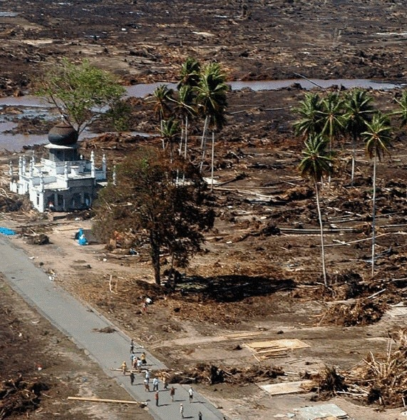
Figure 3

Figure 4

This destructive cycle may repeat many times before the hazard finally passes. Persons caught in the path of a tsunami have little chance to survive. They can be easily crushed by debris or they may simply drown. Children and the elderly are particularly at risk, as they have less mobility, strength and endurance.
Tsunamis typically cause the most severe damage and casualties very near their source. There the waves are highest because they have not yet lost much energy to friction or spreading. In addition, the nearby coastal population, often disoriented from the violent earthquake shaking, has little time to react before the tsunami arrives. The largest tsunamis, however, can cause destruction and casualties over a wide area, sometimes as wide as the entire Pacific Basin. These types of Pacific-wide tsunamis may happen only a few times each century.

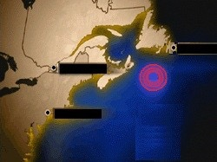

Value
4% 63. Using Figure 2, explain how tectonic forces create a tsunami.

Value
4% 64. Describe two impacts tsunamis have on ecosystems.

Value
6% 65. Identify and explain three ways that a coastal Newfoundland community may reduce the potential impact of a tsunami.

CASE STUDY 1: The Nile River: A Mixed Blessing

Since its beginnings, the Nile river has provided for, as well as taken, life. The Nile becomes increasingly important the farther north it flows into Sudan and Egypt. This is because it brings water to those regions which lie in Earth’s greatest and most desolate desert, the Sahara. Without the blessing of Nile water, Egypt would be as empty as the rest of the Sahara. The Nile River has a total length of 6 695 kilometres from source to sea. This major north-flowing river has two major tributaries, the White Nile and the Blue Nile. The two tributaries converge in Khartoum, the capital of Sudan.

Aswan High Dam Controls the Nile River

Just north of the border between Egypt and Sudan lies the Aswan High Dam, a huge rockfill dam which captures the Nile River. The dam, known as Saad el Aali in Arabic, was completed in 1970 after ten years of work. The reservoir created by this dam was designed to provide Egypt with a reliable source of water for irrigation and hydroelectric power. Water that used to be lost to the sea is now saved. The reservoir of water has helped in periods of drought to turn areas of desert into agricultural land, something that is critical for a country with a very high birthrate and little farmland. Forty-one percent of Egypt’s population are poor and need all the land they can get to grow food for survival.

Figure 1

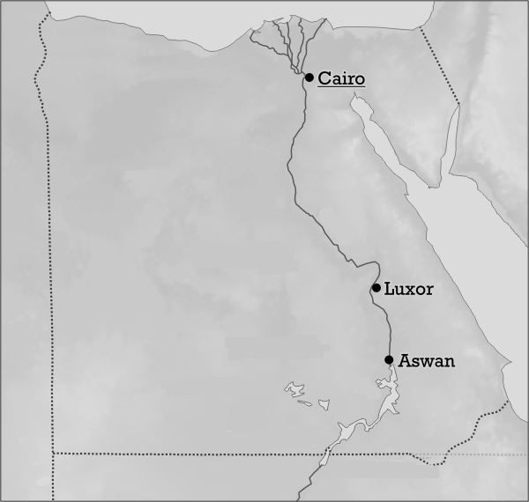
In spite of these great benefits to Egypt, the Aswan High Dam has been a mixed blessing. Much water is lost by evaporation; it is no surprise that rain rarely falls in the Sahara, while evaporation is about three metres annually! The tremendous surface area of the reservoir ensures that a large percentage of the reservoir’s water is lost each year. The reservoir also serves to trap the sediment that once nourished the flood plains of the Nile valley. This is because new soil deposited annually from the floods naturally renewed the soil. Now that the Nile no longer floods downstream of Aswan, artificial fertilizers must be applied to farmland. These fertilizers often end up entering the Nile River through water runoff or other

means. This contaminates the fish and other organisms of the river affecting the food supply. Health problems and increases in waterborne diseases such as cholera have also resulted since the dam was constructed. Culturally, many ancient temples and monuments were drowned by the reservoir.

Eastern Africa: Worst Floods in Decades

Starting in late August and lasting into October 2007, extreme amounts of rainfall caused the river Nile and several seasonal rivers to burst their banks flooding parts of Africa. More than 650 000 people lost their homes and over 200 lives were lost in some of the worst floods in the history of Africa that affected large areas of land all over Eastern, Central and West Africa.
In East Africa, Ethiopia, Sudan, Uganda, Rwanda, Somalia and Kenya were all badly hit. Hundreds of thousands of people were affected (see Table 1).

Table 1

Country | Number of Lives Affected and/or Displaced | Number of Known Deaths
Uganda | 90 000 | 10
Ethiopia | 100 000 | unknown
Sudan | 500 000 | 70
Rwanda | 12 000 | 20

Nothing escaped the fast-moving waters and as a result, farms and livestock, as well as roads, hospitals, and schools were damaged or swept away. Whole communities were left destitute and the flood destroyed 250 schools as well as displacing 56 000 students.

Ibrahim Adam Yusuf, a Sudan resident, said, "We were all worried and we were waist high in water. My house collapsed."

Ibrahim’s daughter suffered from A.W.D. (Acute Watery Diarrhea), a disease which spreads rapidly with floods.

The destruction of crops and grain stores, as well as the death of livestock, affected food security. According to the United Nations, more than 14 000 livestock and 18 000 chickens perished in the floods that swept over 40 000 hectares of agricultural lands in Sudan alone. This caused food shortages to become more widespread. Also, thousands of poorly constructed homes such as those in Figure 2, were washed away or destroyed by the flood waters.

Many of the countries in Eastern Africa are vulnerable and disaster-prone, having been hit by both drought and floods in recent years. In Sudan, there were six major floods between 1990 and 2001 affecting over 1.5 million people. The economic costs were immense - for example in 1999 accumulated losses due to the Nile River flooding and flash floods amounted to over $500 million Canadian.

Livelihoods of East Africans, already hampered by conflicts and poverty, were made worse by these recent floods. Organizations from all over the world were called upon to help out. The Red Cross supplied emergency kits and also helped distribute blankets and essential food items. As well, generous American support aided millions of poor, hungry, citizens. However, despite all of this help there still remains much to be done and much more assistance is needed.

Figure 2

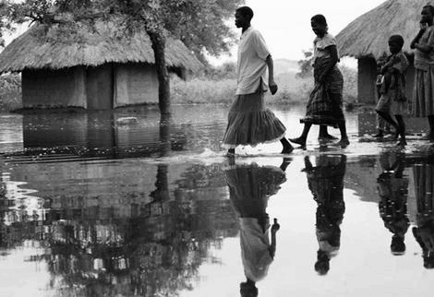

Value
4% 63. Using one example from the case study and one example from your geographical knowledge, explain two ways human activity is influenced by climatic conditions.

Value
4% 64. Countries in East Africa sometimes have problems recovering from disasters such as floods and drought. Based on the case study and your geographical knowledge, what two factors have contributed to this? Explain using social or economic indicators.

Value
6% 65. The construction of the Aswan High Dam has been a mixed blessing for the East African region. Using the case study and your geographical knowledge, identify three problems caused by the Aswan High Dam and propose a solution for each.

CASE STUDY 1: Considering the Effects of Climate Change

Climate change is occurring throughout the world. It is believed that Earth’s temperature rose approximately one degree Fahrenheit during the last century. Most of this warming has been attributed to the large scale use of fossil fuels for vehicles and factories in many industrialized countries such as the United States. This has led to an excessive amount of greenhouse gases in the atmosphere; and, while global warming may benefit some countries, many climatologists are concerned about changes in rainfall patterns, higher local temperatures and rising sea levels which could impact others.

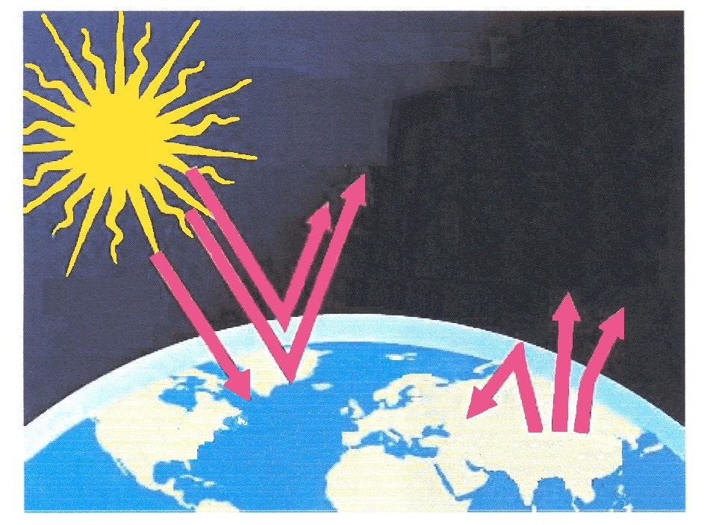
Rising Sea Levels Figure 1

Global warming will significantly impact sea levels. A rise of almost 1.5 metres has been predicted by some climatologists by the year 2050. As a result, many populated areas will be greatly affected. Approximately 15% of Egypt’s farm land, for example, is at risk and significant portions of many coastal cities such as New York and London could go below sea level. Moreover, the consequences of rising sea levels for very densely populated areas of the world,
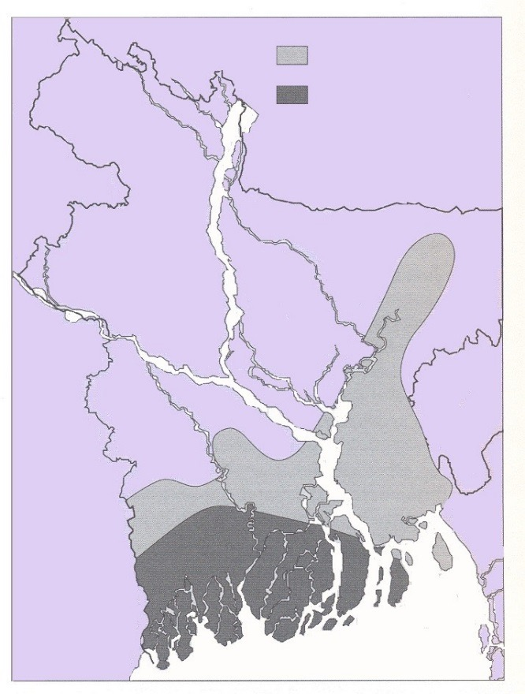
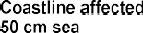
such as Bangladesh, could be disastrous.
Figure 3

Figure 2
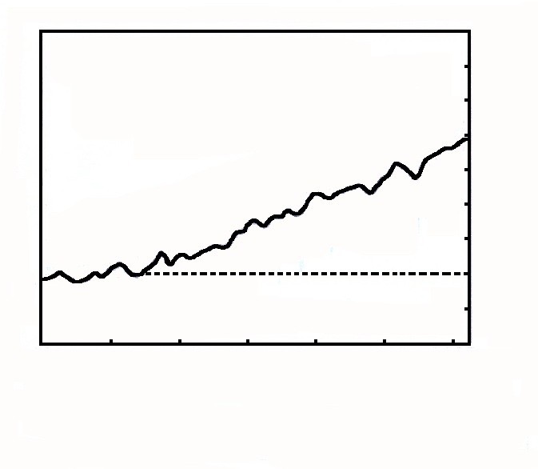

Overview of Bangladesh

Bangladesh is one of the poorest countries in the world with an annual Gross Domestic Product of approximately $2200 U.S. dollars per person. The country is densely populated (1045/km²) and has a large, expanding population with over 150 million people living in a country approximately half the size of Labrador. Over 80% of the population still live in rural areas and almost all are employed in the agricultural sector. While more and more Bangladeshis are moving to urban centres in the hope of becoming prosperous, most migrants become inhabitants of squatter settlements facing challenges such as pollution, over congestion, supply shortages, poverty and crime. Bangladesh’s capital, Dhaka, is not only overpopulated (Pop: 11 000 000) but it suffers from the flooding problems that impact most of the country. For example, in 1970, Cyclone Bhola devastated much of the region, killing an estimated 500,000 people. More than half the city of Dhaka was flooded and millions of people were left homeless.

Flooding in Bangladesh

Bangladesh is a low-lying country with most of its coastline only about 4 to 6 metres above sea level. The country lies at the meeting point of three large rivers; the Ganges, the Brahmaputra, and the Meghna. Floods are normal for this region, yet essential, since they spread fertile soils over large areas. Floods, however, during the monsoon season can be catastrophic especially when it coincides with tidal waves brought on by cyclones within the Bay of Bengal. As a result, tremendous population displacement takes place.

There are no movie theatres in the remote village in southwestern Bangladesh and very few families own a television. There, live theatre is a popular form of entertainment. Recently, theatre groups have performed a play called, “Environmental Thinking: Where Will We Go?” The drama announces a grave warning regarding the region’s ability to withstand floods, storms and saltwater intrusion brought on by global warming and rising sea levels. Shortages of drinking water, disease, loss of animal and human life are key components of the theme song.
Global warming is threatening this area and many others along Bangladesh’s coastline but tens of millions are not interested in moving or simply cannot.

How then should the people of Bangladesh respond? Should solutions be local or global? Many different opinions exist.

“If there is one organizing principle for the government’s approach to climate change, it is that the country must focus on adapting to the changes rather than relocating substantial parts of the population.”

Rafiqul Islam, Dept. of Integrated Coastal Zone Management
“We already have (some) dikes. Now, we need to do two things; raise the height of the dikes …and the drainage structures would have to be changed so that the rainfall inside could be drained out.”

Ainun Nishat, Water Resources Expert
“Passing on the problem of global warming to future generations is like ignoring a government budget deficit. Except with the deficit, there are economical mechanisms that could be put into place to get out of a large deficit. With sea level rise, there is really no technological way to put the ice back in Greenland.”

Overpeck, Scientist

Value
4% 63. Using your geographical knowledge and information from the case study, describe two ways global warming has impacted human activity.

Value
4% 64. Explain how climatic factors and the physical landscape pose environmental risks to Bangladesh.

Value
6% 65. Rafiqul Islam suggests that adapting to climate change is preferable to relocating Bangladesh’s people. Using three arguments to support your position, explain why you agree or disagree with this point of view.

