Unit 3: Ecosystems Name: __________________
Public Exam Practice Questions
Part A: Multiple Choice

- According to the diagram below, which number would represent producers?
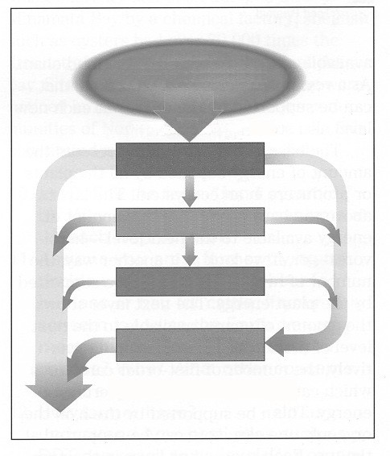

(A) | 1
(B) | 2
(C) | 3
(D) | 4

- Which is an example of biological amplification?

  - hawks dying from eating prey exposed to insecticides
  - lake trout dying from exposure to a chemical spill
  - sea birds dying from exposure to an oil spill
  - trees dying from exposure to acid rain

- According to graphic below, which would be the most favourable soil for farming?
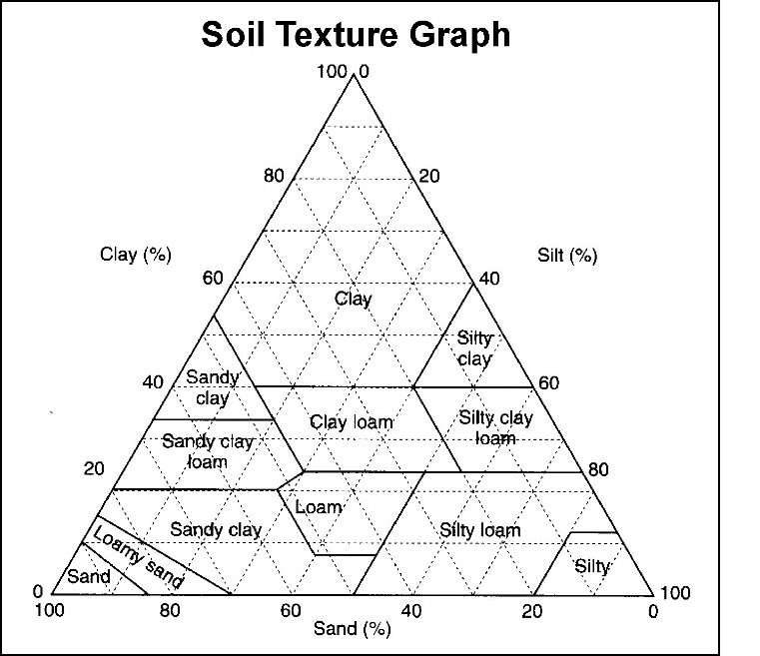

  - 10% sand, 40% clay, 50% silt
  - 20% sand, 60% clay, 20% silt
  - 30% sand, 30% clay, 40% silt
  - 50% sand, 40% clay, 10% silt

- According to the map below, which region would be most at risk due to the removal of the rain forest?

(A) | 1
(B) | 2
(C) | 3
(D) | 4
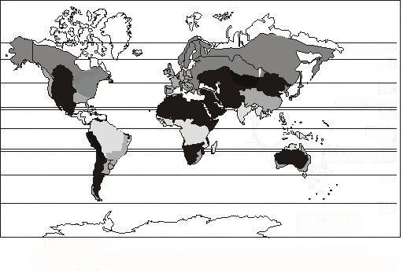
- Which is a community of plants and animals within a particular physical environment?

  - ecosystem
  - food chain
  - food web
  - pyramid

- What regions are associated with thick forests of coniferous trees, long snowy winters, and summers with moderate temperatures?

- boreal forests
- temperate forest
- tropical rainforest
- tundra

- According to the chart below, which continent has the highest percentage degraded drylands?

Continent | Total Agriculturally Used Drylands | Degraded Drylands
Australia | 701.21 | 375.92
Europe | 145.58 | 84.28
North America | 578.18 | 328.62
South America | 420.67 | 305.81

- Australia
- Europe
- North America
- South America

- Which best describes energy flow throughout an ecosystem?

  - Decomposers obtain energy from 3rd level consumers only.
  - Energy flows from 3rd level consumers to 2nd level consumers.
  - 10-15% of energy is passed from one trophic level to the next.
  - There is no energy transfer from one trophic level to the next.

- Which world ecosystem matches the description below?
•
•
•
long, snowy winters
summers have moderate temperatures
vegetation is dominated by thick forests of needle-leaf trees
  - boreal forest
  - savanna
  - scrub
  - temperate forest

- Which pattern best describes the change in ecosystems from polar regions to the equator?

  - boreal forest º temperate forest º tropical rain forest º tundra
  - boreal forest º temperate forest º tundra º tropical rain forest
  - tundra º boreal forest º temperate forest º tropical rain forest
  - tundra º boreal forest º tropical rain forest º temperate forest

- Which refers to the relationship between living and non-living elements of a region?

  - ecosystem
  - food chain
  - food web
  - trophic level

- Which forest ecosystem is described below?
- broad-leaf trees
- loses leaves in winter
- warm summer temperatures
  - boreal
  - coniferous
  - temperate
  - tropical rain

- Which explains why toxins concentrate at the top of the food pyramid?

  - Top consumers are the primary target of pesticides.
  - Top consumers receive all the energy and toxins from producers.
  - Toxins are fat soluble and at each higher level become more concentrated.
  - Toxins are found in water and higher order consumers drink more.

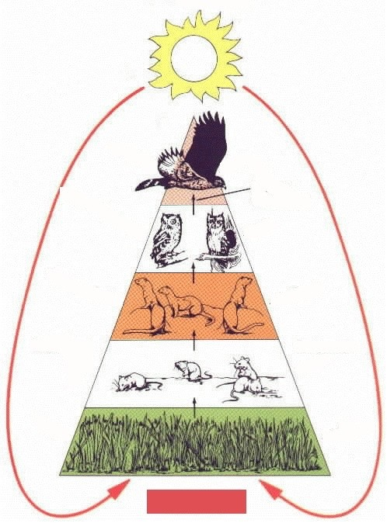
- Why are there fewer organisms at higher levels in the food pyramid?

  - Decomposers transfer energy to the higher levels.
  - Most of the energy is contained in the highest level.
  - Organisms at the higher trophic levels receive energy from the sun.
  - There is a loss of energy as you move from one trophic level to the next.

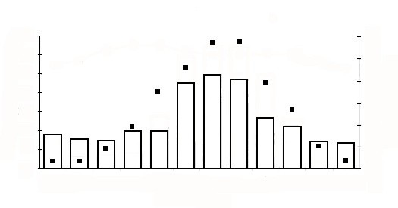
- Which ecosystem would be found in the climatatic region below?
  - boreal forest
  - marine west coast
  - savanna
  - temperate grassland

- Which factor contributes most to increased soil fertility?

  - capillary action
  - eluviation
  - humus accumulation
  - leaching

- What does the diagram below best represent?
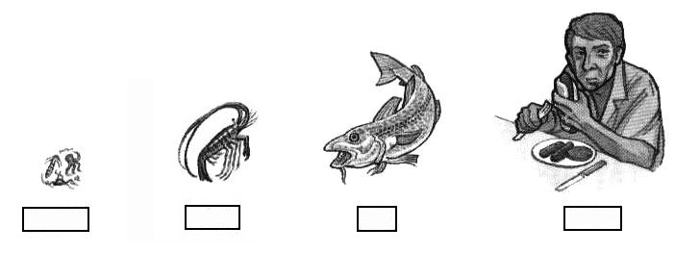

  - decomposers
  - ecosystem
  - food chain
  - food web

- Which best explains why there are fewer organisms at the top of a food pyramid?

  - energy is lost from the bottom trophic level to the top
  - organisms at the top trophic level eat less food to get energy to survive
  - the available energy is constant through all trophic levels
  - there is less energy available at lower trophic levels

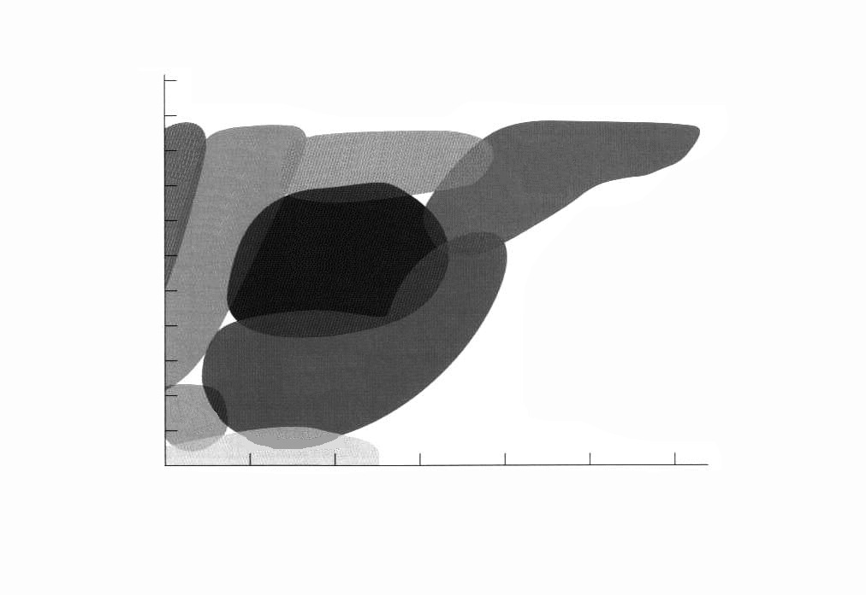
- Which world ecosystem is defined as having annual temperatures between 23ºC – 27ºC and precipitation between 100 cm - 150 cm per year?

  - desert
  - grassland
  - savanna
  - tropical rain forest

Part B: Short Answer
Value
4% 23. Using the sources below and your geographical knowledge, explain two ways human activity has threatened our environment and describe one solution for each threat.
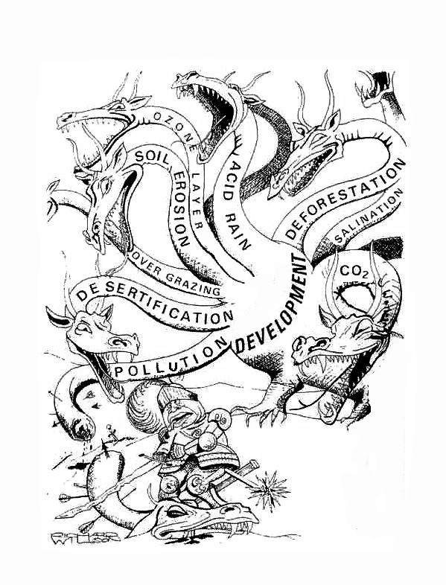

4% 24. Explain why the owl could be greatly impacted by a pesticide introduced at the primary trophic level.
